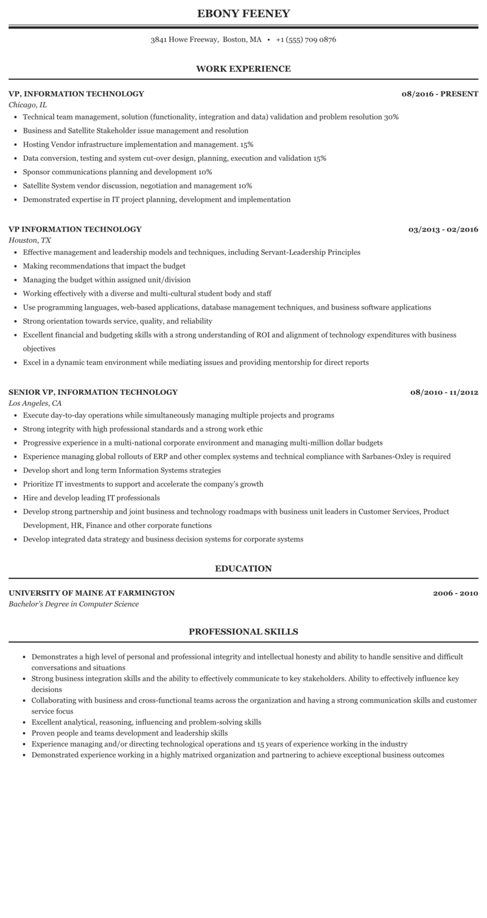
EBONY FEENEY
3841 Howe Freeway, Boston, MA +1 (555) 709 0876
WORK EXPERIENCE
VP, INFORMATION TECHNOLOGY
Chicago, IL
• Technical team management, solution (functionality, integration and data) validation and problem resolution 30%
⚫ Business and Satellite Stakeholder issue management and resolution
⚫ Hosting Vendor infrastructure implementation and management. 15%
⚫ Data conversion, testing and system cut-over design, planning, execution and validation 15%
• Sponsor communications planning and development 10%
⚫ Satellite System vendor discussion, negotiation and management 10%
• Demonstrated expertise in IT project planning, development and implementation
08/2016 - PRESENT
VP INFORMATION TECHNOLOGY
Houston, TX
• Effective management and leadership models and techniques, including Servant-Leadership Principles
• Making recommendations that impact the budget
• Managing the budget within assigned unit/division
• Working effectively with a diverse and multi-cultural student body and staff
03/2013 - 02/2016
• Use programming languages, web-based applications, database management techniques, and business software applications
• Strong orientation towards service, quality, and reliability
• Excellent financial and budgeting skills with a strong understanding of ROI and alignment of technology expenditures with business objectives
• Excel in a dynamic team environment while mediating issues and providing mentorship for direct reports
SENIOR VP, INFORMATION TECHNOLOGY
Los Angeles, CA
• Execute day-to-day operations while simultaneously managing multiple projects and programs
• Strong integrity with high professional standards and a strong work ethic
• Progressive experience in a multi-national corporate environment and managing multi-million dollar budgets
08/2010-11/2012
• Experience managing global rollouts of ERP and other complex systems and technical compliance with Sarbanes-Oxley is required
• Develop short and long term Information Systems strategies
• Prioritize IT investments to support and accelerate the company's growth
⚫ Hire and develop leading IT professionals
• Develop strong partnership and joint business and technology roadmaps with business unit leaders in Customer Services, Product Development, HR, Finance and other corporate functions
• Develop integrated data strategy and business decision systems for corporate systems
UNIVERSITY OF MAINE AT FARMINGTON
Bachelor's Degree in Computer Science
EDUCATION
2006-2010
PROFESSIONAL SKILLS
• Demonstrates a high level of personal and professional integrity and intellectual honesty and ability to handle sensitive and difficult conversations and situations
• Strong business integration skills and the ability to effectively communicate to key stakeholders. Ability to effectively influence key decisions
• Collaborating with business and cross-functional teams across the organization and having a strong communication skills and customer service focus
• Excellent analytical, reasoning, influencing and problem-solving skills
• Proven people and teams development and leadership skills
• Experience managing and/or directing technological operations and 15 years of experience working in the industry
• Demonstrated experience working in a highly matrixed organization and partnering to achieve exceptional business outcomes

